Adverbs of Place

🔹 What Are Adverbs of Place?
# Source: AI Source: Provided by: [Data Path: Persons Table -> ID Column: 1, Name_En Column: Motasem Essam] -> From: [Chatgpt (GPT-4-turbo)] on [7/27/2025]
Adverbs of place tell us where something happens.
They describe the location, direction, or movement of an action, and answer the question: 👉 "Where?"

✅ Common Adverbs of Place
# Source: AI Source: Provided by: [Data Path: Persons Table -> ID Column: 1, Name_En Column: Motasem Essam] -> From: [Chatgpt (GPT-4-turbo)] on [7/27/2025]
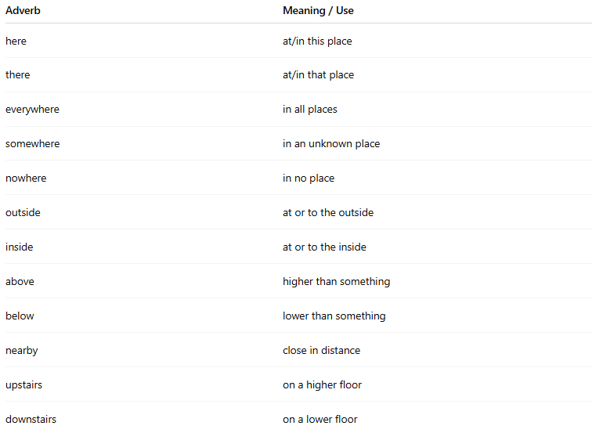
Adverb | Meaning / Use
here | at/in this place
there | at/in that place
everywhere | in all places
somewhere | in an unknown place
nowhere | in no place
outside | at or to the outside
inside | at or to the inside
above | higher than something
below | lower than something
nearby | close in distance
upstairs | on a higher floor
downstairs | on a lower floor

📚 Examples in Sentences
# Source: AI Source: Provided by: [Data Path: Persons Table -> ID Column: 1, Name_En Column: Motasem Essam] -> From: [Chatgpt (GPT-4-turbo)] on [7/27/2025]
- Please wait here.
- He lives nearby.
- I looked everywhere, but I couldn’t find it.
- The kids are playing outside.
- She went upstairs to sleep.

🧠 Key Notes
# Source: AI Source: Provided by: [Data Path: Persons Table -> ID Column: 1, Name_En Column: Motasem Essam] -> From: [Chatgpt (GPT-4-turbo)] on [7/27/2025]
- Usually placed after the verb or verb + object:
✅ They walked there.
✅ She put the books inside.
- Can also begin a sentence for emphasis:
✅ Outside, the wind was howling.
- Some can also be used as prepositions, but in this case, they are pure adverbs when they stand alone (no noun after them).

